BWJP Digital Media/Communications Coordinator (Temporary)

BWJP is the national non-profit leader at the intersection of gender-based violence and the law. BWJP is a dynamic collection of national policy and practice centers which provide support, education, best practice, and innovation to advocates, systems professionals, community leaders, and policy experts. BWJP advocates for survivors of gender-based violence with both civil and criminal resources, training, and consulting. We believe in creating systemic change that acknowledges the nuances and complexities that exist within the world of gender-based violence.

Position Overview:

BWJP is seeking an individual to coordinate, and backend manage two websites. One is WordPress based and the other is on a custom server which will entail learning the system. The coordinator will catalog and map out all resources on both websites, looking for missing information, outdated documents, take inventory of how the organization is showing up digitally, and finding ways of how we can improve. This individual will create compelling social media campaigns from resources and tools available on our websites. They will also monitor the analytics of both websites and work with the SEO manager on implementing new SEO best practices.

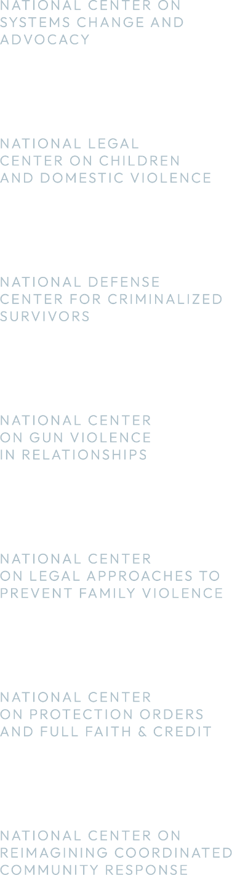

Key Job Responsibilities:

- Works closely with relevant staff to understand the needs and goals of the National Center on Gun Violence in Relationships.
- Coordinates and catalogs all digital media on www.bwjp.org and preventdvgunviolence.org websites.
- Identifies gaps in information on the websites and recommends content to fill in gaps.
- Creates graphics for websites and social media around gun violence and domestic violence.

Skills and Qualifications
- Creativity paired with strong judgment and organizational skills.
- Bachelor’s degree or equivalent professional work experience.
- Collaborative, team player; high level of professionalism, courtesy, tact, and diplomacy.
- Ability to learn independently.
- MUST be highly proficient with WordPress backend.
- SEO experience
- Adobe Creative Suite and/or Canva experience and understanding of design basics.
- Proficient with Microsoft 365 and Google Suites
- Organized and meticulous proof-reading skills
- Knowledge and understanding of Hootsuite and all social media platforms.
- Be abreast of digital marketing and social media trends.
- A strong commitment to ending gender-based violence and diversity, equity, and inclusion principles.

Salary: $25-30/hourly x 8 weeks. The Digital Media/Communications Coordinator is a part time/temporary position expected to be funded until May 31, 2023.
Benefits: This is not a benefit eligible position.

Application: Please submit your resume, cover letter, and writing sample by March 31, 2023, to hr@bwjp.org, or Battered Women’s Justice Project, 540 Fairview Ave N, Suite 208, St. Paul, MN 55104

