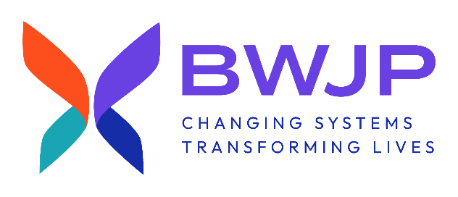
POSITION: Human Resources Manager

About Us:
BWJP is the national non-profit leader at the intersection of gender-based violence and the law. BWJP is organized as a dynamic collection of national policy and practice centers which provide support, education, best practice, and innovation to advocates, systems professionals, community leaders, and policy experts. BWJP advocates for survivors of gender-based violence with both civil and criminal resources, training, and consulting. We believe in creating systemic change that acknowledges the nuances and complexities that exist within the world of gender-based violence.

Position Summary:

The Human Resources Manager will lead all functions of BWJP’s human resources including hiring and interviewing staff, administering pay, benefits, and leave, and ensuring company policies and practices are mission-based and enforced fairly and within the scope of the law. Reporting to the Director of Operations, the HR Manager is responsible for the day-to-day management and implementation of human resources policies and practices for BWJP board, staff, interns, and volunteers. This position also negotiates contracts for the benefits of the organization as well as provides the infrastructure and support for all employee management and retention including staff policies, on/off boarding of staff, performance reviews, support to Directors, and other HR needs as directed by the CEO and Director of Operations.

Responsibilities:

Supervisory Responsibilities:
- Recruits, interviews, hires, and trains new staff in the department.
- Oversees the daily workflow of the department.
- Provides constructive and timely performance evaluations.
- Handles discipline and termination of employees in accordance with company policy.

Duties/Responsibilities:
- Continues to improve the staff onboarding, retention and exit processes. Works with the Executive team to ensure that organizational needs are addressed throughout the implementation of these processes.
- Partners with the leadership team to understand and execute the organization’s human resource and talent strategy particularly as it relates to current and future talent needs, recruiting, retention, and succession planning.
- Provides support and guidance to BWJP staff when complex, specialized, and sensitive questions and issues arise; may be required to administer and execute routine tasks in delicate circumstances such as providing reasonable accommodations, investigating allegations of wrongdoing, and terminations.
- Ensures that the mission-driven Employee Handbook and Board of Director Handbook are updated on an annual basis and presented in a timely fashion for Board of Director approval.
- Manages the talent acquisition process, which may include recruitment, interviewing, and hiring of qualified job applicants, particularly for managerial, exempt, and professional roles; collaborates with supervisors to understand skills and competencies required for openings.
- Confidentially supports the Board of Directors in employment investigations of the CEO. Confidentially supports the CEO and Director of Operations in employment investigations of all other staff.
- Analyzes trends in compensation and benefits; researches and proposes competitive base and incentive pay programs to ensure the organization attracts and retains top talent.
- Creates learning and development programs and initiatives that provide internal development opportunities for employees.
- Oversees employee disciplinary meetings, terminations, and investigations.
- Maintains compliance with federal, state, and local employment laws and regulations, and recommended best practices; reviews policies and practices to maintain compliance.
- Maintains knowledge of trends, best practices, regulatory changes, and new technologies in human resources, talent management, and employment law.
- Interfaces with BWJP’s outsourced accounting firm to coordinate employee benefits and support ADP payroll system.
- Manages HR platforms, like ADP/ADP Workforce, to keep confidential employee files maintained.
- Other duties as assigned.
Qualifications

Education and Experience:
- Bachelor’s degree in Human Resources, Business Administration, or related field required. BWJP will consider candidates without a Bachelor’s degree if they has 5+ years experience directly in HR.
- A minimum of three years of human resource management experience preferred.
- SHRM-CP or SHRM-SCP highly desired.

Required Skills/Abilities:
- Excellent verbal and written communication skills.
- Excellent interpersonal, negotiation, and conflict resolution skills.
- Excellent organizational skills and attention to detail.
- Strong analytical and problem-solving skills.
- Ability to prioritize tasks and to delegate them when appropriate.
- Ability to act with integrity, professionalism, and strict confidentiality.
- Thorough knowledge of employment-related laws and regulations.
- Proficient with Microsoft Office Suite or related software.
- Proficiency with or the ability to quickly learn the organization’s HRIS and talent management systems.
- Experience with ADP Workforce, insurance brokers and other venders as needed,
Compensation and Logistics

Salary: $70,000-$89,000 per year based on experience, plus a comprehensive benefits package, e.g. health, dental, vision, retirement, short/long term disability and life insurance, vacation, sick, and holiday pay.

Preferred location: BWJP’s administrative office is in St. Paul, MN with opportunities to work virtually. BWJP has a significant virtual staff presence nationally and will consider virtual candidates dependent on experience. Typical hours are 8:30 am- 4:30 pm CT; there will be evening or weekend work and national travel on occasion.
Application:
Send a cover letter and resume to Jeanne Larson, HR Manager at: hr@bwjp.org (please include Human Resources Manager in the subject line) or BWJP 540 Fairview Avenue North, Suite 208, St. Paul, MN 55104. Please be prepared to submit three references upon request.
AA/EOE

