Summer 2024 Internship Program

BWJP is a national 501(c)(3) non-profit organization dedicated to addressing all issues related to gender-based violence. BWJP has seven centers, each offering specialized policy and practice initiatives to improve survivor safety. We strive to create systemic change and maintain a perspective that prioritizes the safety and well-being of marginalized communities.

BWJP is currently seeking applications from current law school students for our Summer 2023 Internship Program. The program will run for 10 weeks from May 17, 2024, to July 26, 2024. These are fully remote unpaid positions. All interns will participate in training events and most if not all interns, will have opportunities to shadow staff members in internal and external-facing meetings.

The following BWJP centers are seeking applications:

- The National Center on Protection Orders and Full Faith & Credit (NCPOFFC)
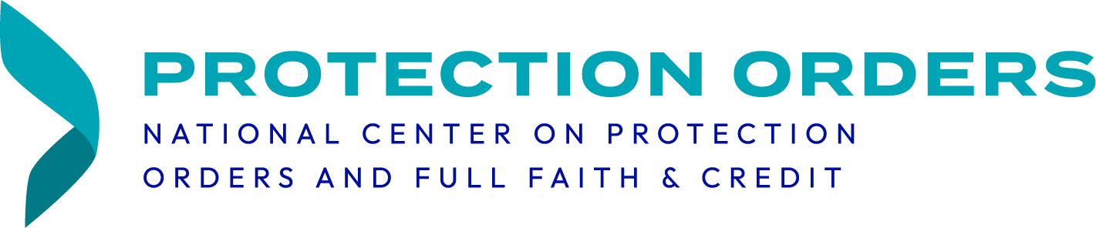
NCPOFFC provides technical assistance and training on the full faith and credit provision of the Violence Against Women Act, issuance, service, and enforcement of protection orders, enforcement of federal and state firearm prohibitions as they relate to domestic violence, custody provisions in protection orders, and federal domestic violence and stalking crimes.

NCPOFFC seeks a diverse group of current law students to participate in our program. Interns will be responsible for conducting research and policy analyses on a variety of topics including relevant federal and state statutes, protection order issuance, service, and enforcement, and the full faith and credit provision of VAWA. Interns will also assist in writing and editing NCPOFFC’s publications and other like resources.

We prefer law students with an legal research and writing and an interest in civil and criminal justice issues surrounding intimate partner violence, protection order enforcement. Applicants should be able to work independently since this internship will be fully remote. Completion of criminal law and constitutional law courses is preferred but not required.

- The National Defense Center for Criminalized Survivors (NDCCS)
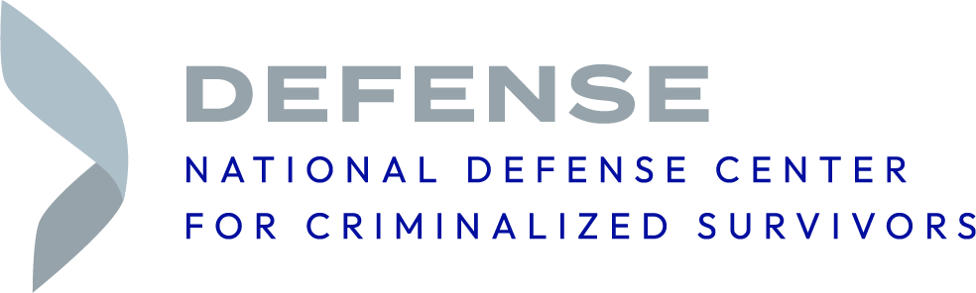

The National Defense Center for Criminalized Survivors, formerly known as the National Clearinghouse for the Defense of Battered Women, addresses the unique needs of victims of gender-based violence who have been criminalized as a result of their experiences of being abused.

We provide specialized technical assistance, resources, and support for victims and their defense teams. Equally important, we train and build alliances among national, state-wide, and local organizations to improve justice for survivors everywhere.

NDCCS is seeking a legal intern for the summer of 2024. The legal intern’s duties will vary depending on organizational needs and the student’s interests and skills. This ten-week internship will likely include legal research of recent court decisions and statutes affecting victims of battering charged with crimes and assisting the legal team with other various legal projects or tasks as otherwise assigned.

We would prefer students with experience working in the areas of domestic violence and criminal defense. The legal intern must have excellent writing skills.

- The National Center on Legal Approaches to Prevent Family Violence (NCLAPFV)

The National Center on Legal Approaches to Prevent Family Violence (NCLAPFV) promotes civil and criminal legal system practices that interrupt violence in families, improve survivors’ access to court and offer supports that prevent future violence.

NCLAPFV seeks two rising 2L or 3L law students to assist with various legal and policy research, analysis, and writing. The Center is currently focused on pretrial practices, alternatives to policing and access to justice, and seeks law student assistance in related research and writing. The Center also supports the legislative and policy work of state and Tribal domestic violence coalitions and seeks law student assistance with state-level policy work around domestic violence.

The Center disseminates our legal policy analyses to a wide audience around the country. For this reason, we seek highly motivated law students with strong research skills and excellent writing skills.

- The National Center on Reimagining Coordinated Community Response (NCRCCR)
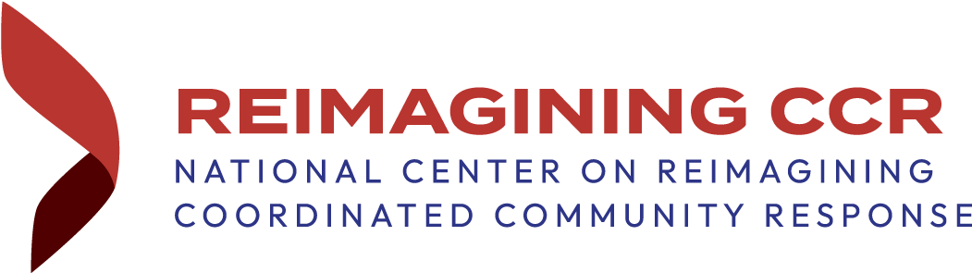

NCRCCR establishes approaches and support for centering survivor and culturally specific realities, for advocates and allied professionals to positively shift systems’ interactions with survivors, and their partners and communities.

NCRCCR is seeking interns who are interested in learning about systemic reform and how to strategically assess systemic interventions, address poor outcomes for marginalized survivors and promote equitable responses for all survivors. The following are the legal interns’ responsibilities:

- Aid in the development of assessment tools and resource materials for improving the equity and cultural relevance of systemic responses to intimate partner violence.
- Research and develop a database of diverse community-based responses to intimate partner violence.
- Participate in training events, meetings, and policy discussions.
- Assist in the writing and editing of newsletters, publications, and other resources.

Preferred qualifications include:

- Research and legal writing skills.
- Strong computer skills and proficiency in the use of Lexis and other online legal search tools.
- Demonstrated interest in civil and criminal justice issues surrounding intimate partner violence and CCR.
- Ability to work with others and independently as needed.
- Strong organizational skills and detail oriented.
- Knowledge of intimate partner violence. Knowledge of dating violence, sexual assault, and stalking is preferred, but not required.
- Completion of criminal law courses is preferred, but not required.

5) The National Center on Gun Violence in Relationships
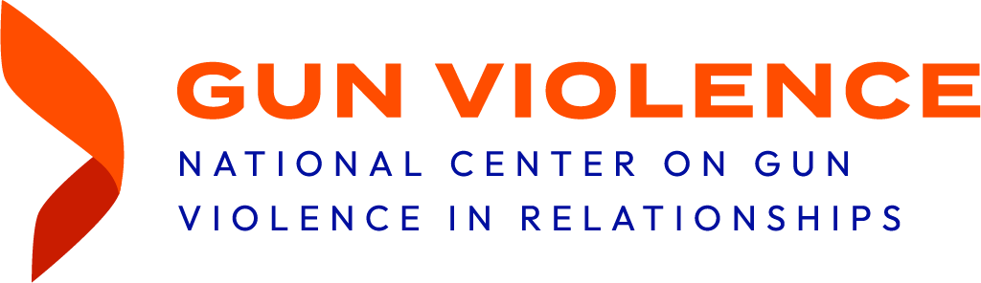
The National Center on Gun Violence in Relationships works to prevent domestic violence-related homicides involving firearms; provide quality practice and policy expertise; build the capacity of practitioners to proactively address domestic violence and firearms; and we manage the Safer Families, Safer Communities website— the comprehensive online clearinghouse of information on the intersection of domestic violence and firearm violence. BWJP’s Gun Violence Center manages the National Resource Center on Domestic Violence and Firearms (NRCDVF) and the Firearms Technical Assistance Project (FTAP), funded by the Office on Violence Against Women, US Department of Justice.

The National Center on Gun Violence in Relationships is seeking applications from individuals studying law, criminal justice, public health, or social work. The following are the interns’ responsibilities:

- Aid in the development of resource materials for multidisciplinary professionals aimed at increasing knowledge and effective implementation and enforcement of laws and policies affecting the intersection of intimate partner violence and gun violence
- Aid in the development of materials for the public aimed at increasing awareness of the intersection of intimate partner violence and gun violence
- Research, analyze and synthesize applicable laws, policies, legislative text, and social science
- Participate in meetings, trainings, events and policy discussions

Preferred qualifications for legal intern include:
- Excellent legal research and legal writing skills.
- Strong computer skills and proficiency in the use of Lexis and other online legal search tools.
- Demonstrated interest in civil and criminal justice issues surrounding intimate partner violence and gun violence.
- Ability to work with others and independently as needed.
- Strong organizational skills and detail oriented.
- Knowledge of intimate partner violence. Knowledge of dating violence, sexual assault, and stalking is preferred, but not required.
- Knowledge of gun violence is preferred, but not required.
- Completion of criminal law and constitutional law courses is preferred, but not required
- Proficient with Microsoft Office Suite and Google applications

Preferred qualifications for public health intern include:
- Must be currently enrolled in or have completed a Master of Public Health (MPH) degree program and eligible for field placement as determined by the sending university.
- Ability to work with others and independently as needed.
- Experience with data analysis and research methodologies
- Strong organizational skills and detail oriented.
- Knowledge of intimate partner violence. Knowledge of dating violence, sexual assault, and stalking is preferred, but not required.
- Knowledge of gun violence is preferred, but not required.
- Proficient with Microsoft Office Suite and Google applications

Preferred qualifications for social work intern include:
- Must be currently enrolled in, or have completed, a Master of Social Work (MSW) degree program and eligible for field placement as determined by the sending university.
- Ability to work with others and independently as needed.
- Strong organizational skills and detail oriented.
- Knowledge of intimate partner violence. Knowledge of dating violence, sexual assault, and stalking is preferred, but not required.
- Knowledge of gun violence is preferred, but not required.
- Excellent verbal and written communication skills
- Excellent observational and listening skills
- Patient demeanor with the ability to relate to, empathize with, and show compassion for a variety of personalities
- Individual initiative
- Ability to work collaboratively as a member of a dynamic team of professionals
- Proficient with Microsoft Office Suite and Google applications

6) National Legal Center on Children and Domestic Violence
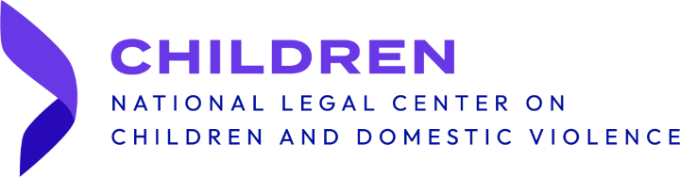
The National Legal Center on Children and Domestic Violence exists to improve safety for gender-based violence survivors and their children. We do this by centering the needs and lived experiences of survivors and their children and providing evidence-informed expertise to system practitioners, advocates, and survivors. Since 2009, NLCCDV has been at the forefront of providing training and technical assistance on child custody and family court matters by developing the SAFeR Approach to custody decision-making in family law matters.

We are here to help advocates, attorneys, court staff, custody evaluators, dispute resolution professionals, Guardian-ad-Litem, judicial officers, and other allies who make decisions on custody, child support, or child welfare for families. Our team specializes in providing technical assistance, consultations, and training that are tailored to each unique situation. NLCCDV provides expertise, training and problem solving to address the intersection of GBV and children’s issues.

NLCCDV is seeking a rising 2L or 3L law student for the summer of 2024. The legal intern’s duties will vary depending on organizational needs and the student’s interests and skills. This ten-week internship will focus on the intersection of child welfare and domestic violence and include legal research of state laws, regulations, and practices on how child neglect allegations and custody determinations are handled in domestic violence situations. The legal intern will research best practices and provide recommendations on system improvements to better protect victims of intimate partner violence and their children.

The Center seeks a highly motivated law students with strong research skills and excellent writing skills. Knowledge of intimate partner violence, dating violence, sexual assault, and stalking is preferred, but not required.

Application:
Applications should include a cover letter, resume and a writing sample that does not exceed 10 pages. In the cover letter, applicants must specify which center they are applying to. Please pick only one center in your application. The deadline to submit applications is March 20, 2024, and we will reach out to candidates who have been selected for an interview in March-April 2024. Applicants should e-mail their complete applications to the HR Manager at: hr@bwjp.org.

The above statements are not intended to encompass all functions and qualifications of this position; rather, they are intended to provide a general framework of the requirements of the position. Incumbents may be required to perform other functions not specifically addressed in this description.

